Bike Share Analysis

With roots dating back to the 1960s, bike sharing has seen an increase in usership with the advent of modern technology for renting and tracking bikes (1). Several publications compare cities regarding biker use and most note a general increase in bike use trends (2). Many questions are still left unanswered regarding this biking community. What demographics make up this community? When are people most likely to rent bikes? How much energy is saved by bike usage per year? By looking at Bluebikes rental datasets I gathered information to begin investigating these questions.

While Boston is known for its car traffic and confusing roadways, one thing that it is not known for is its biking community. Bluebikes is one bike rental company attempting to change that reputation. Established in 2011, Bluebikes boasts more than 260 bike stations in the metro area and intends to expand to over 3,000 bicycles by the end of 2019. With a ‘ridership’ of 5.7million in 2017, there is plenty of data to extrapolate from this city (3).

The datasets I used contained data from 2018 for each ride of every Bluebike in Boston. Information was split into 12 datasets for each month of the year. Each dataset included the station of departure and station where the bike was returned, the time spent in transit, the time of day the ride occurred, and information on the rider if that rider was a BlueBikes subscriber. Rider information included birth year and gender.

The information I uncovered suggested that BlueBike riders tend to be males (over 70% in November) who are 30 years old (median age =30, mean = 33.5) and who are likely students or young professionals in academia based on their frequently visited stops. They mostly ride in the summer to early fall months. This information can be used by BlueBikes to market toward and expand their demographics. Offering incentives to ride during the off-season, or to invite friends for discounts can possibly result in greater ridership and greater profits.

Boston’s Bicyclists

As with any business, knowing the target audience can help hone marketing efforts to increase usership. Who are the bikers of Boston? What marketing tools can be used to attract more users in the target demographic and how can the company expand that demographic? To narrow this broad question, I look at the gender and age of the bike users and at the stations used most to surmise what type of profession or background these bikers come from. Although this data set did not provide a legend to their gender input (0,1,2), a quick email uncovered that 0 = no input, 1=male and 2=female. Using this knowledge, a clear gender discrepancy was found in the data:

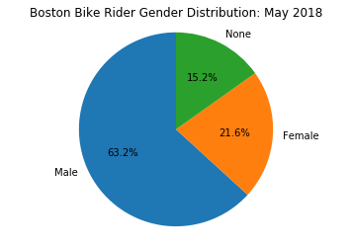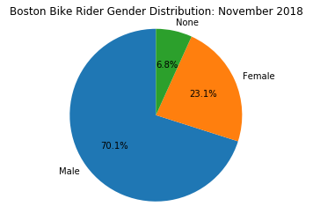

I analyzed Nov 2018 as it is currently the most complete and recent dataset available and May 2018 to see how trends differ due to time of year. Riders are predominantly male throughout the year (>70% in November and >60% in May). As BlueBikes is partnered with Blue Cross Blue Shield of Massachusetts, advertising to female patients via email may be a feasible way to help increase ridership with this demographic.

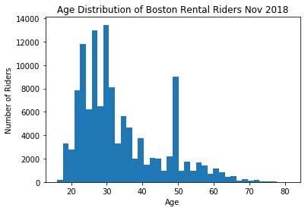Looking at the age distribution of rental riders, a trend for individuals in their mid-late twenties is evident for both May and November, with a curious spike in individuals roughly 48-50 years old. Further delving into the data is required to deduce what may be a technical error skewing the birth year upon registration. The bike rider median age is 30 years old, making that demographic characterized by the ‘millennial’ generation.

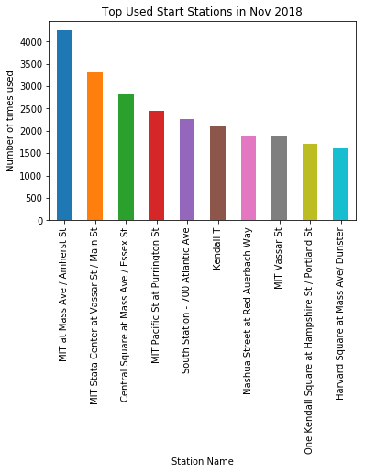To further understand individuals using BlueBikes, I looked at the most commonly used bicycle stations in Boston. Of the top stations, most preoccupy territory closely surrounding academic institutions (MIT is heavily represented, and Harvard also has a popular station) with only two stations to note in areas that are further from academic institutions. These stations may be frequented by tourists (South Station) or possibly sports fans attending a Bruins/Celtics game (Nashua Street).

Noting that this data may be skewed by a high student population in November compared to the middle of summer, I also looked at July’s station stops and found only a few differences. MIT is still the largest represented area, but Beacon St, Copley Square, and City Hall, all areas of tourist attraction and financial/government use are also represented. However, there are several colleges and universities in these areas as well.

Taking all this data together, it is possible that the typical BlueBikes user is a millennial male in academia, possibly as a graduate student, or in an early professional setting. This information can be used by BlueBikes to increase revenue. At each bicycle station, advertisements targeting this demographic can be sold. Discounts can be offered towards this group via a BlueBikes app to incentivize individuals to invite friends to become members.

When is peak season?

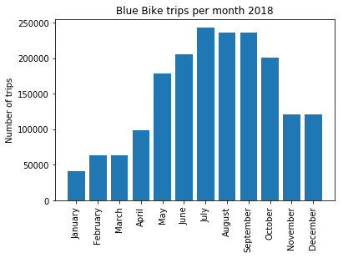Although probably not novel to note, biking is more popular in the summer time with July representing the highest bike use. Ridership remains high in October before plummeting with minimal resurgence before May. Using this information, BlueBikes can offer special rates for members joining in off seasons to entice riders during the slower months.

Energy Savings

Touted for their ability to save energy by taking cars off the roads, bike share systems have the potential to save fuel. But does the cost of their infrastructure outweigh the carless benefit?

Most are solar-powered, so the only upfront cost is the installation. Many configurations do not require elaborate construction as they do not extensively modify the existing infrastructure to install. (4)

To therefore answer this question fully, I need to look at the distance traveled by the bikes and calculate the amount of gas it would cost for a car to travel that distance. Taking an assumption based on the national average mile/gallon performance for a vehicle, I can calculate on average, how much energy a bike would save. Another false assumption that I must work with is the assumption that all bikes travel directly from the ‘start’ station to the ‘end’ station. This is incorrect for the obvious reason that bikes cannot travel *as the crow flies*, particularly in Boston, where roadways are never straightforward. Thus, our energy cost estimate will be highly conservative in nature as most cyclists will travel farther than the data suggests.

Future Research

For future research, an important question to elucidate is ‘Why do Boston riders bike ride?’ The answer to this can help with advertising: The most common reasons can be used to pull people into the biking community who have similar interests and reasons for wanting to ride. To answer this question, a survey can be sent to existing members with multiple choice options for “Why do you bike ride?” Options could include: For exercise, because it saves me money, because I don’t like to drive, because I can’t drive, because it’s environmentally friendly, and other. From responses, summary statistics and visualizations can be used to determine the prevailing factor(s) driving usership.

Comparisons of city ridership have already been conducted by other rental companies, but it would be interesting to ask this ‘biking motive’ question across the country and analyze how the responses differ geographically.

Looking further into the available data, uncovering what time of day riders commute could help the company to regulate biking fairs and offer discounts during times of slower ridership. To analyze this, I will need to clean the data for the Trip Start Time Series as it is set to 12-hour time rather than 24 hour time. This is a current obstacle as I do not currently know how to convert this data within python using the ‘AM’ and ‘PM’ strings.

Finally, revisiting the data to better understand the spike in usership in the late 40s would important for marketing and added knowledge of the biking community. This may be a portion of the data set that needs to be cleaned due to a technical error or may be representative of the population. Perhaps there is a large group of people in their late 40s who participate in frequent group rides. Further analysis is required to fully understand this group of data.

1. DeMaio, P. (2009). Journal of Public Transportation, Vol. 12, No. 4, https://www.nctr.usf.edu/jpt/pdf/JPT12-4DeMaio.pdf
2. **Bike Share in the U.S.: 2017. National Association of City Transportation Officials.** https://nacto.org/bike-share-statistics-2017/
3. The History of BlueBikes (2018). https://www.bluebikes.com/about
4. NACTO: Bike Share. Station Siting Guide. 2016. https://nacto.org/wp-content/uploads/2016/04/NACTO-Bike-Share-Siting-Guide_FINAL.pdf

**Describe your dataset**. Describe and explore your dataset in the initial section of your Report. What does your data contain and what is its background? Where does it come from? Why is it interesting or significant? Conduct summary statistics and produce visualizations for the particular variables from the dataset that you will use.

**Ask and answer analytic questions**. Ask three analytic questions and answer each one with a combination of statistics and visualizations. These analytic questions can focus on individuals behaviors or comparisons of the population.

**Propose further research**. Lastly, make a proposal for a realistic future research project on this dataset that would use some data science techniques you'd like to learn in the bootcamp. Just like your earlier questions, your research proposal should present one or more clear questions. Then you should describe the techniques you would apply in order to arrive at an answer.

*Extrapolating further, I can calculate the total energy savings with national user data.